Unified Modeling Language (UML) Diagrams for

Online Student Materials Management System

Table of Contents

1. Introduction to UML Diagrams 1

1.1 Use-Case Diagram 1

1.2 Class Diagram 1

1.3 Sequence Diagram 1

1.4 Activity Diagram 1

1.5 State Machine Diagram 1

2. Use-Case Diagram 2

3. Class Diagram 3

4. Sequence Diagrarm 4

5. Activity Diagram 5

6. State Diagram 6

# Introduction

UML diagrams are a kind of blueprint for software systems. They use a specific visual language to represent the different parts of a system and how they work together. This makes it easier for developers to design, understand, and document complex software. Here's a brief overview of some common types of UML diagrams:

## Use-Case Diagrams

This diagram focuses on the functionality of a system from the user's perspective. It shows the actors (users or external systems) that interact with the system and the use cases (functions) that the system provides for those actors.

## Class Diagram

This diagram dives into the system's internal structure. It shows the different classes (blueprints for objects) that make up the system, the attributes (data) of those classes, and the operations (methods or functions) that the classes can perform. It also shows the relationships between these classes, such as inheritance and association.

## Sequence Diagrams

This diagram shows how objects interact with each other in a specific scenario. It depicts the objects involved as vertical lifelines, and horizontal arrows represent messages exchanged between them. This helps visualize the flow of communication in a particular use case.

## Activity Diagrams

This diagram focuses on the flow of control within a system. It shows the different activities that are performed, the sequence in which they occur, and the decisions that need to be made along the way. It's useful for modeling workflows and business processes.

## State Machine Diagrams

This diagram shows the different states that an object can be in and how it transitions between those states in response to events. It helps visualize the dynamic behavior of an object and how it reacts to different stimuli.

Each type of UML diagram serves a specific purpose in the software development process and can be used at different stages to capture different aspects of the system. They help in visualizing, analyzing, and communicating complex systems, fostering better understanding among team members and stakeholders.

# Use-Case Diagram

# Class Diagram

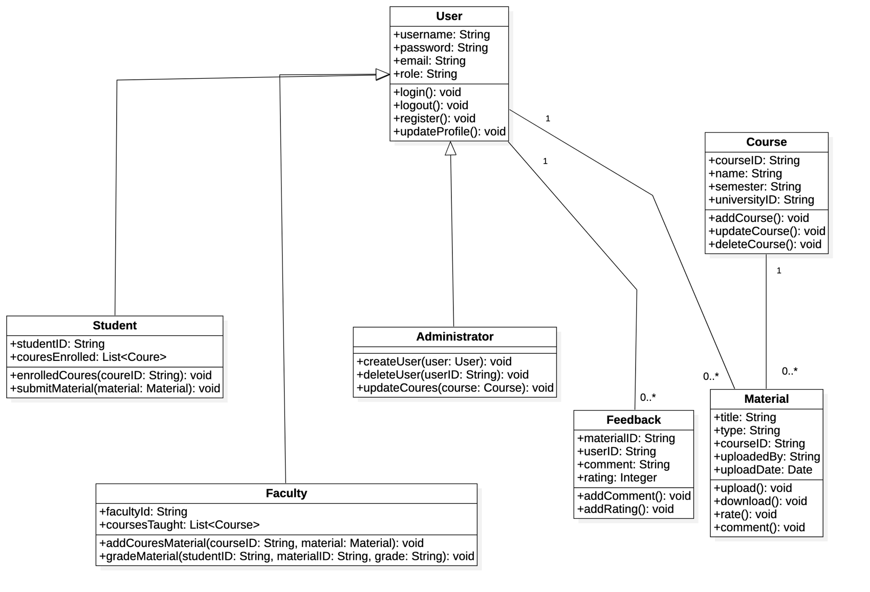

# Sequence Diagram

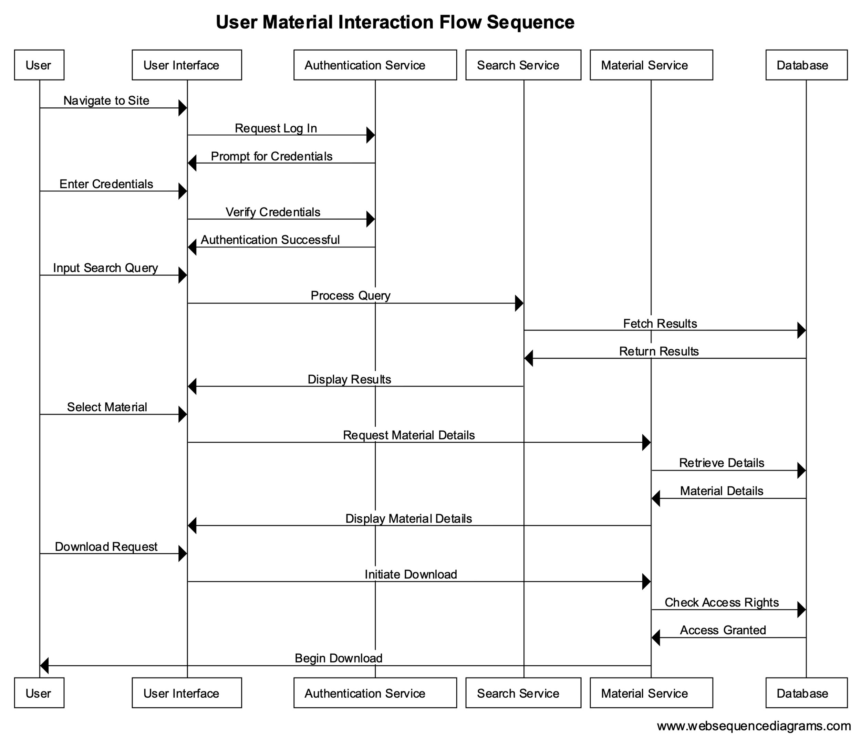

# Activity Diagram

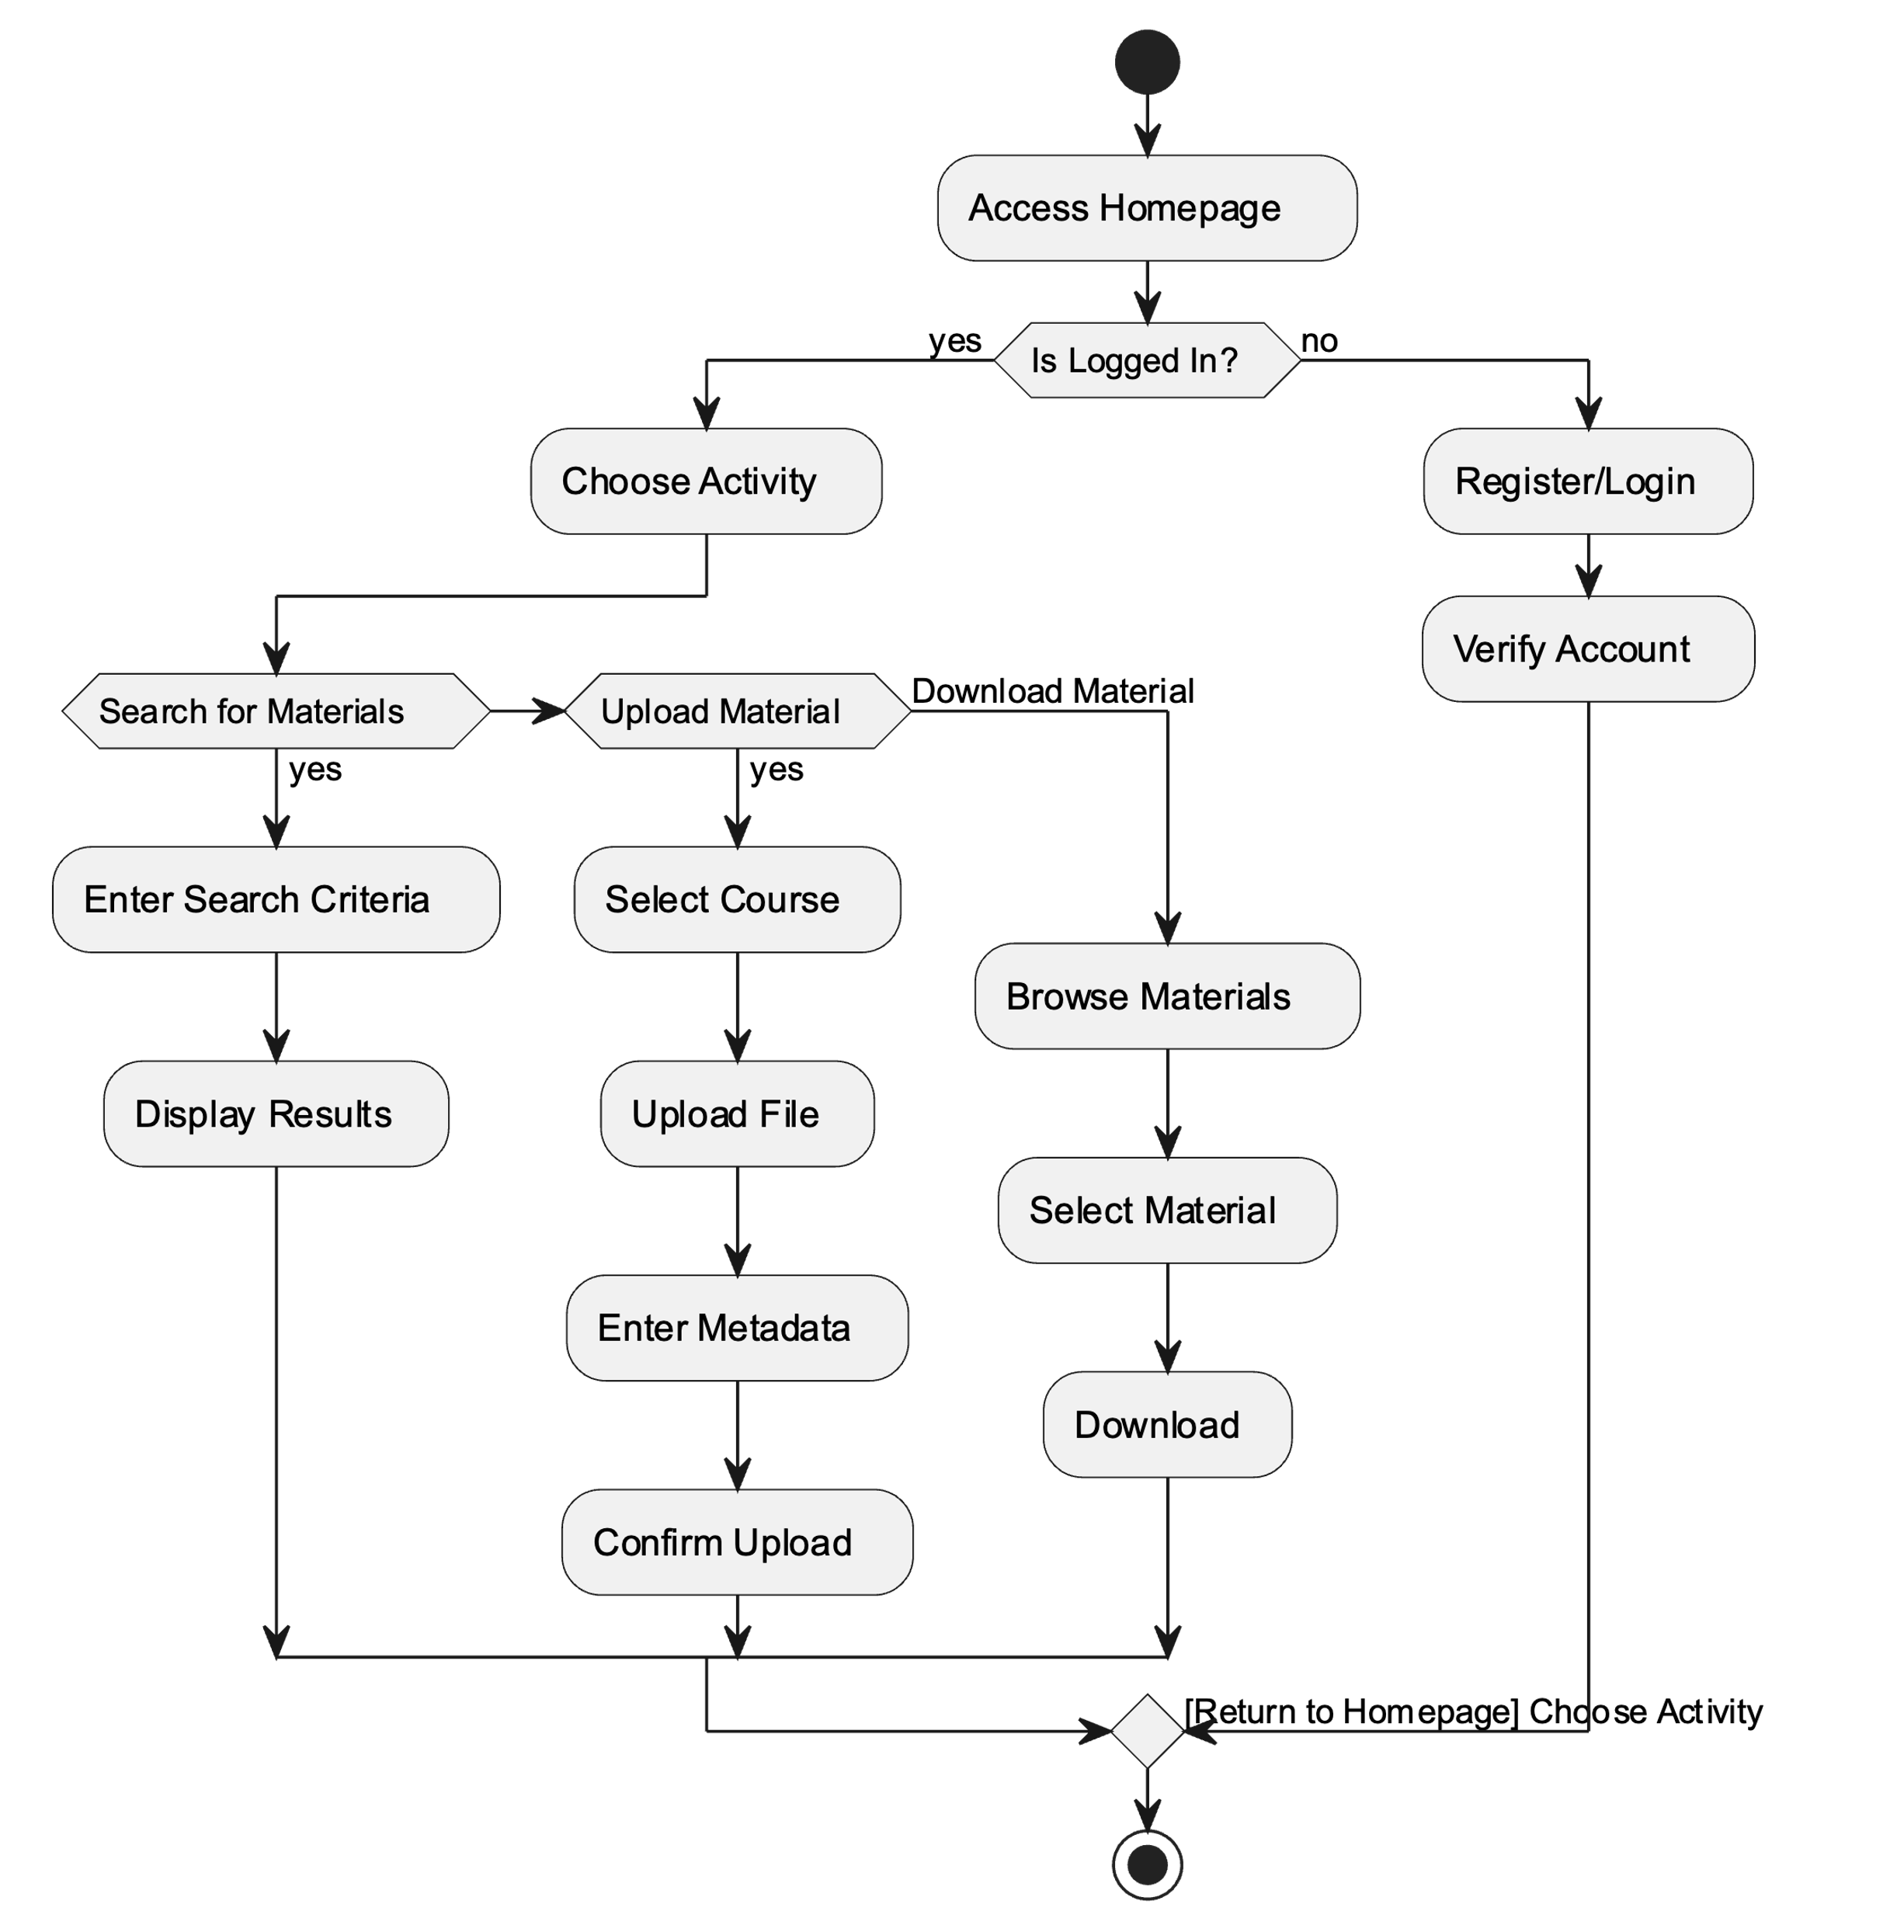

# State Diagram

